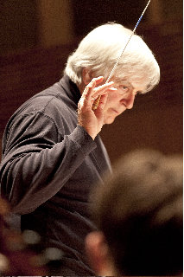
Anthony Antolini graduated from Bowdoin College and holds graduate degrees from Stanford University in music and Slavic studies. He is a member of the music faculty at Bowdoin College in Brunswick, Maine, where he conducts the Bowdoin Chorus and Rachmaninoff Choir and teaches music
theory. In 1988 he published the first modern, bilingual edition of Sergei
Rachmaninoff's Liturgy of St. John Chrysostom. His award-winning
television documentary on this subject, Rediscovering Rachmaninoff, has
been broadcast on public television nationally. In 1999 Antolini was a
featured speaker at the national convention of the American Choral
Directors Association (ACDA) in a presentation entitled "American Choirs
Can Sing Russian Choral Music". He has also done similar presentations for
the Eastern Division ACDA on Slavic and Greek choral music in 2000 and
2008. His editions of choral music are published by E.C. Schirmer and
Paraclete Press. He was elected by the Maine Chapter of ACDA as "Conductor
of the Year" for the 1999-2000 season. Antolini's most recent publication
is a new performance edition of Rachmaninoff's All-Night Vigil (also known as the Vespers), released in November, 2011, by E.C. Schirmer. He is
currently at work on a bilingual edition of Igor Stravinsky's Les Noces
(The Village Wedding) arranged for chorus, soloists, percussion and piano
four hands. Antolini is also Music Director at the Episcopal Church of
St. John Baptist in Thomaston, Maine, Music Director of Down East Singers
in Rockport, Maine, and a faculty member of the New England Suzuki
Institute at St. Joseph's College in Standish, Maine. In the summer of
2012 he became Music Director of the Lincoln Festival Chorus in
Boothbay Harbor, Maine.

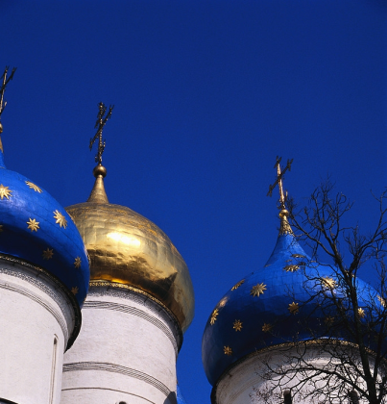

COME JOIN US & SING
A FESTIVAL OF RUSSIAN SACRED
CHORAL MUSIC

November 10, 2012
St. James’s
Episcopal Church
1991 Mass. Ave., Cambridge MA 02140

Have you always loved the rich sonorities and spiritual depth of Russian Orthodox choral music? Now is your chance to
COME SING IT YOURSELF!
Be part of the
Russian Festival Choir
at St. James’s Episcopal Church

SATURDAY NOVEMBER 10th,
9 AM to 4 PM
with
CONCERT AT 3 PM
WHO WILL PERFORM?
The Russian Festival Choir will be made up of singers like you from all over the greater Boston area and even from Maine, prepared and directed by well-known Russian sacred music specialist and choral director Dr. Anthony Antolini. If you can read music and have sung in a church or other choir, you are welcome to join us! Registration is only $15.00 per person, to cover the cost of your music packet. Lunch on November 10th will be on your own.

HOW WILL WE LEARN THE RUSSIAN CHORAL STYLE?
We will arrive at St. James’s at 1991 Mass. Ave., Cambridge at 9 AM with the notes prepared. Dr. Antolini will spend the morning teaching us pronunciation of the Church Slavonic for the pieces we perform in the original language and then go on to introduce us to the unique Russian sacred choral singing style. At noon we will lunch on our own in the Porter and Davis Squares, an easy walk from St. James’s. At 1 PM, we’ll re-gather at the church and polish our performance for the concert.

THE CONCERT WILL BE AT
3 PM IN THE CHURCH,
OPEN TO ALL WHO WISH TO HEAR US SING!
HOW DO I GET INVOLVED?
Simply register using the form on the other side of this brochure, and all the sheet music will be sent to you by the end of September. We ask that you learn the notes on your own and do your best with the pronunciation of the transliterated Old Church Slavonic. That way, our time in rehearsal on November 10th can be spent polishing pronunciation and the unique style of Russian sacred choral singing.

WHAT WILL WE SING?
•Sergei Rachmaninoff Liturgy of St. John Chrysostom: #12 Tebye poyem (To Thee O Lord) & #20 Final blessing. Sung in Slavonic.
•Sergei Rachmaninoff All-Night Vigil: #1 Priidite, poklonimsya (Come, let us worship) & #6 Bogoroditse Devo (Ave Maria). Sung in Slavonic.
•Dmitri Bortniansky: Cherubic Hymn #7. Sung in English.
•Igor Stravinsky: Otche nash (The Lord's Prayer). Sung in Slavonic & English.
•Michail Ippolitov-Ivanov: Bless the Lord, O my soul (Psalm 104: 1-2, 6 10, 24.) Sung in English.
•Pavel Chesnokov: Salvation is Created,
Sung in English.

REGISTRATION
Open to all music readers age 14 & up
Name _______________________________________

Choral Part _________________________________
Name of your home choir
______________________________________________

Phone no. ___________________________________

Email _______________________________________

Street No. & Name (to send your music)
_______________________________________________

City_______________State____Zip______________
Send by Sept. 30th with $15.00 for music costs to:
St. James’s Episcopal Church,
1991 Massachusetts Ave., Cambridge MA 02140

